Person 1: 22
Cleaning a stove

- Mix ‘spick in span’ in water to dilute
- Spray mixture on stove
- Wipe stove
- Takes coils off
- Spry under coils
- Wip under coils
- Put coils back on (hard if you don't remember where they went)
- Then wipe with water

Hate having to do it because there is only one person that does it so it’s super dirty when they do it.
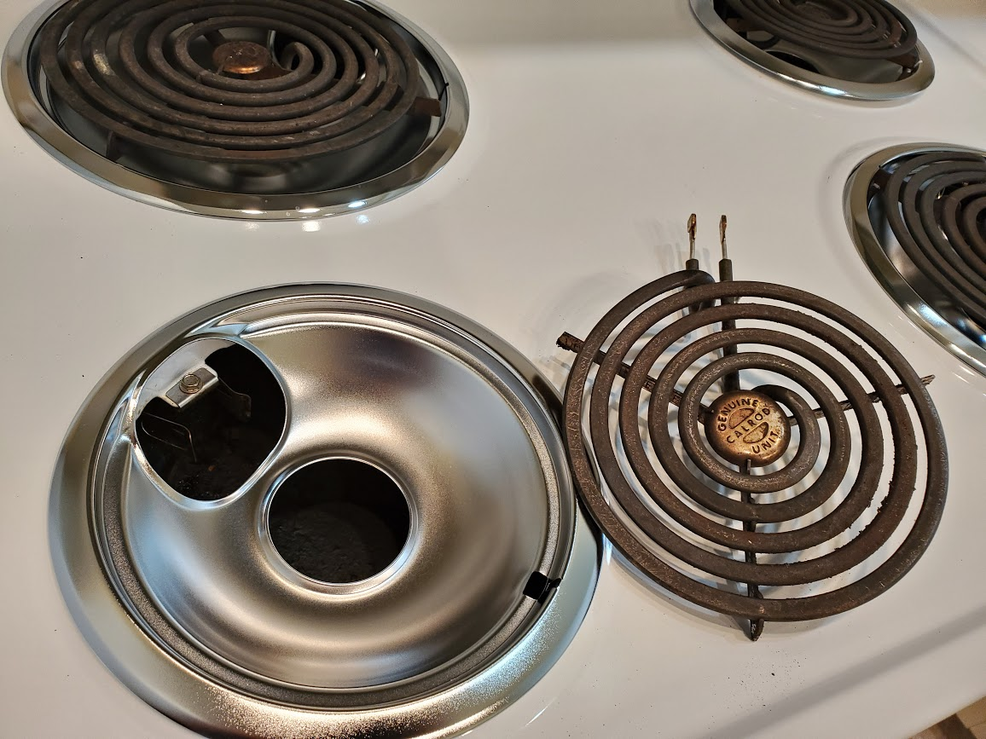
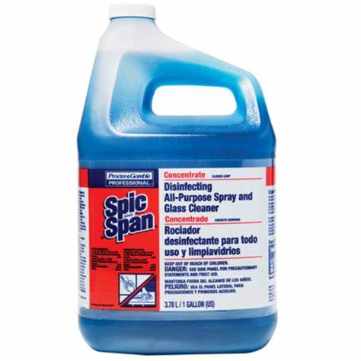
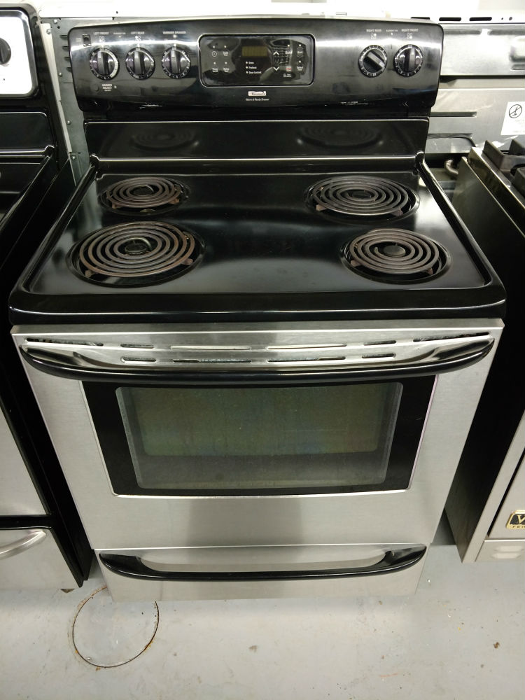
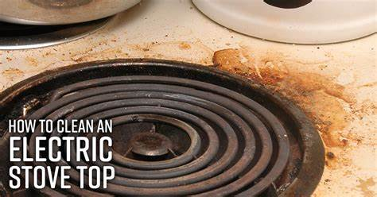
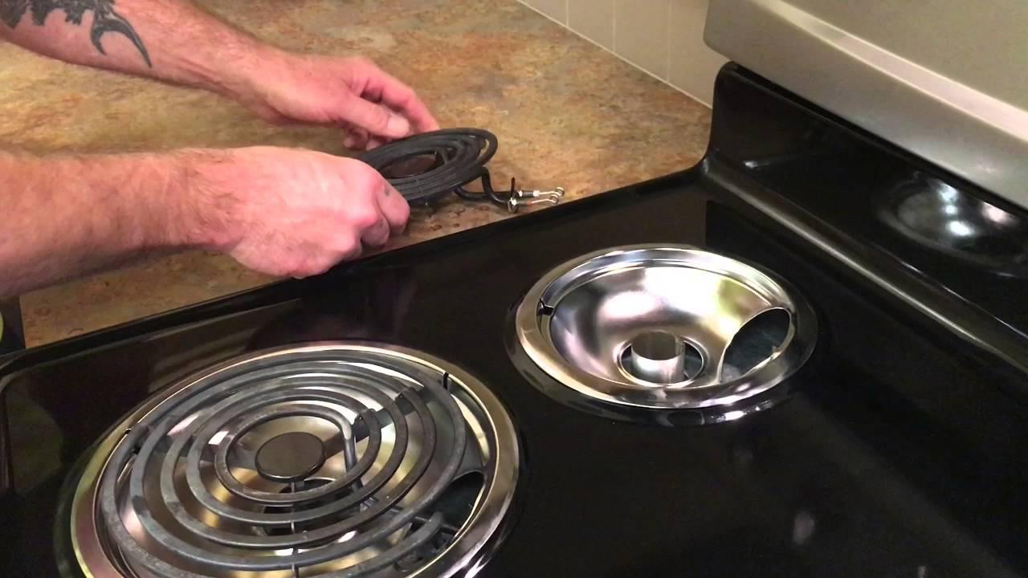
Person 2: 20
Going to bed

- Wake up
- Get through the day
- Look at the time on the clock and realize you need to go to bed at 1:00 am
- Get changed and ready for bed while really tired
- Get in bed but wait there's more!
- Try to sleep
- Open your phone when you can go to sleep
- Pass out on phone

Wanna sleep all day but when opportunity arises you realize you have stuff to do then procrastinate then become really tired and not want to do anything but can’ sleep SO THE CYCLE CONTINUES.
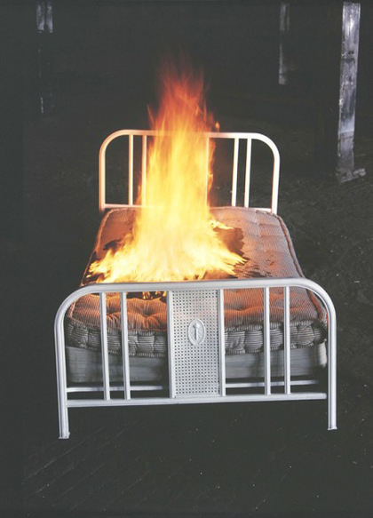


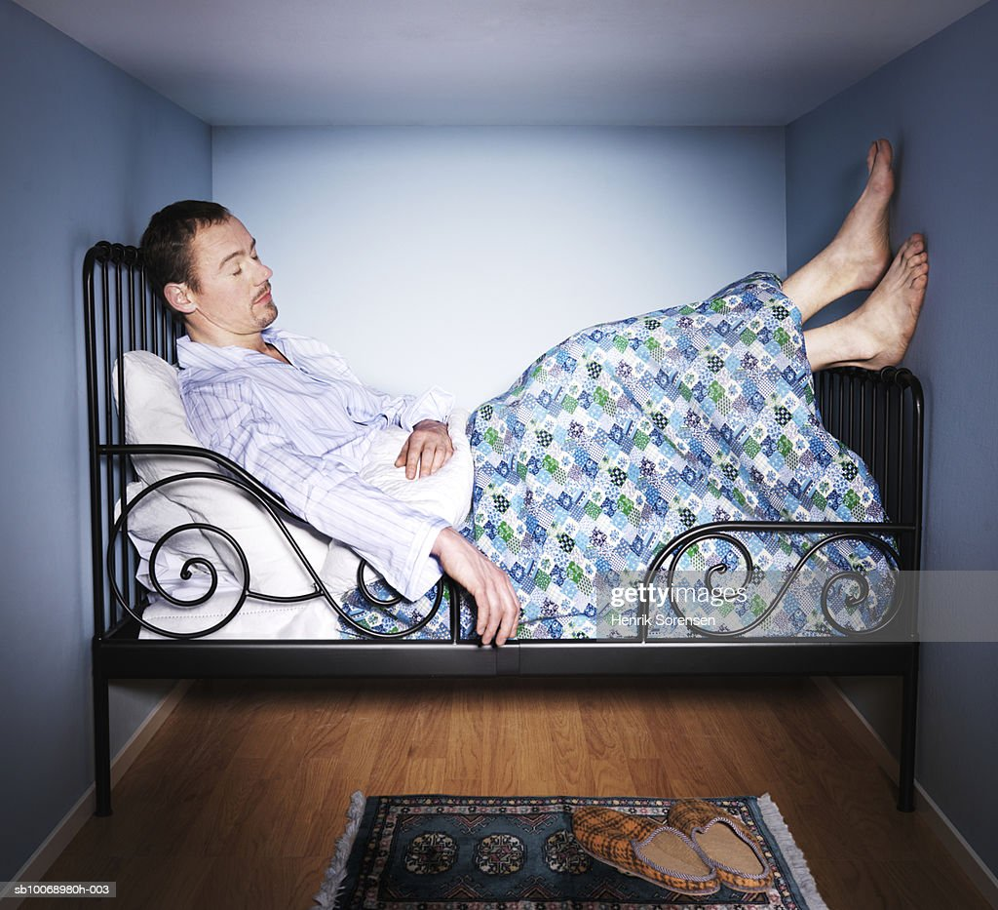
Person 3: 21
Trying to decide what to wear

- Getting and image in head
- Assembling the clothes you have
- Seeing what you can work with
- Deciding if you want to wear it

Cause it takes too long to figure out what you want due to being indecisive.
